CAS PY 106

In-class Note 6

1. Energy needed to add 3rd charge
2. 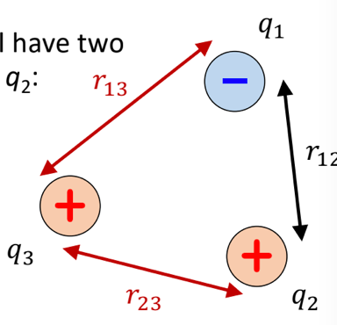
3. First method: U = k\*q1\*q2/r
4. Second method: use potential V and U =q\*V
5. How much energy is needed to move it closer?
6. Electric potential (V)
7. U is analogous to F, quantity calculated between Two or more charges
8. V is analogous to E and describes how space is altered by charge

U = k \* q1 \* q2/r (between 1 and 2)

U = k \* q (test) \* q 🡪 where q(test) is the point we are at

V = U/q(test)

1. Combining equations above, we get

V = kq/r

U = q\*V

1. Potential near two charges
2. 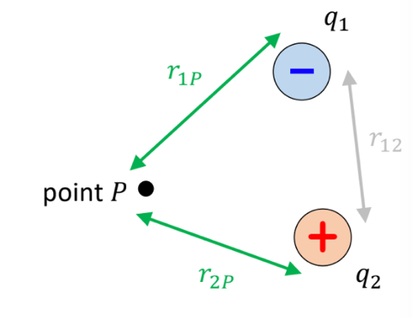
3. V (at P) = k \* q1/ r1 + k\*q2/r2
4. Potential V at any given point is sum of all potentials
5. Adding 3rd charge at point P
6. Energy required to move charge q3 from very away (V = 0, radius is very high) to the point P is:

U(initial) = q3 \* V (initial) = 0

U(final) = q3 \* V (final) = q3 \* V (at P) where V (at P) = k \* q1/ r1 + k \* q2 / r2

Change in U = U (final) – U (initial) = q3\* (k \* q1/ r1 + k \* q2 / r2)

Change in U = k\*q1\*q3/r1 + k\*q2\*q3/r2